Annex H
(informative)
Example of file transfer management
This example gives the specific messages sent and the actual contents of the key message data elements, although any other data elements may also be sent.
The following parameters are assumed:
a) file transfer is initiated by the card issuer;
b) transfer consists of two files.
Table H.1 gives the details of how the Data record data element is configured for each file. Figure H.1 shows the messages flows and Table H.2 to Table H.7 give the relevant data element contents.

Table H.1 — File transfer details
Transfer details | File 1 | File 2
Length of file (bytes) | 5120 | 1400
Number of elementary data records | 20 | 14
Frequency of acknowledgement | 1 | After final message

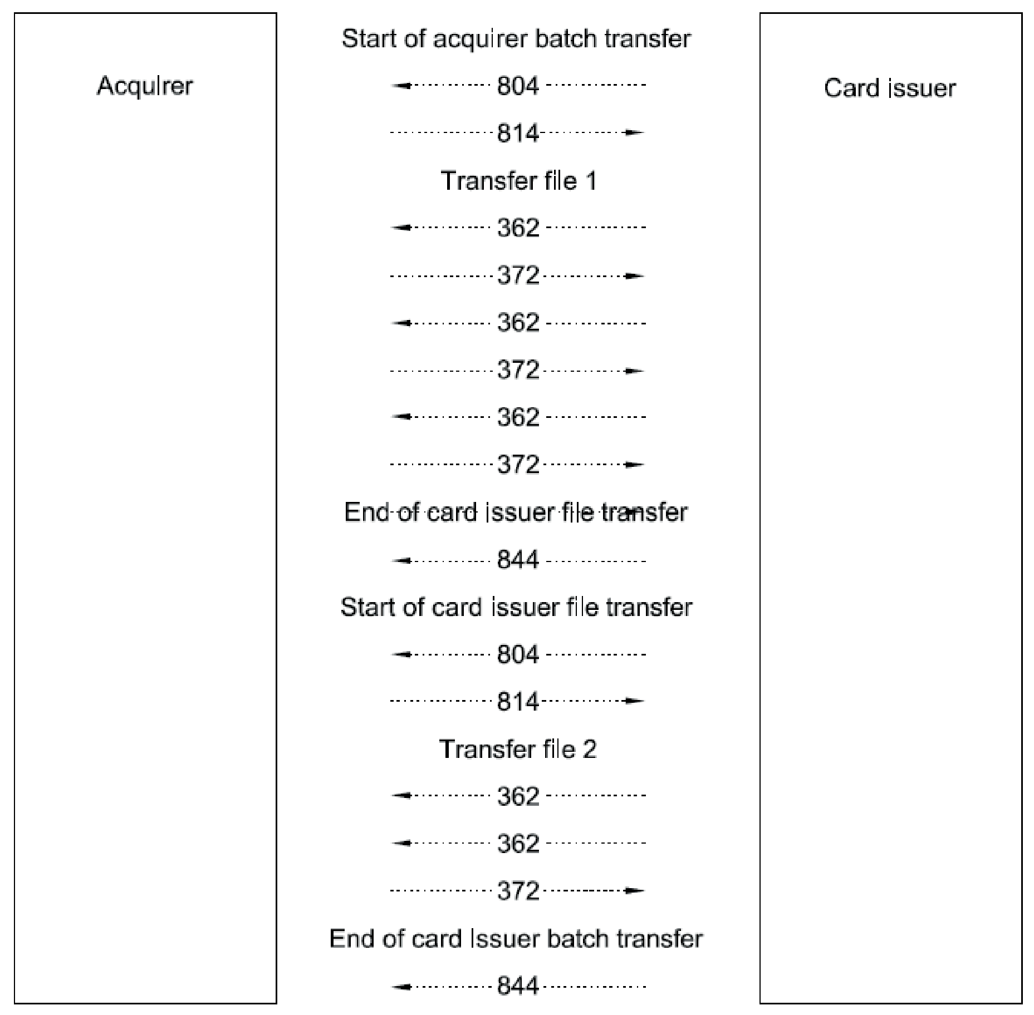

Figure H.1 — Example file transfer

Table H.2 — Start of file transfer
MTI | Bit | Data element name | Value | Meaning
804 | Card issuer to acquirer
 | 24 | Function code | 841 | Start file transfer
 | 25 | Message reason code | 8000 | Start transfer, no recovery procedure
 | 69 | Batch/file transfer control data
 |  | Batch/file transfer message count | 00000003 | Number of messages in the files
 |  | Batch/file transfer file identification | ..test file 1 | File name
 | 70 | File transfer description data
 |  | File transfer file size | 005120 | File size in bytes
 |  | File transfer elementary data record count | 000020 | Number of elementary records in file
 |  | File transfer remaining data record count | 000020 | Remaining number of elementary records
814 | Acquirer to card issuer
 | 24 | Function code | 841 | Start file transfer
 | 39 | Action code | 8000 | Accepted
 | 69 | Batch/file transfer control data
 |  | Batch/file transfer message count | 00000003 | Number of messages in the file
 |  | Batch/file transfer file identification | ..test file 1 | File name
 | 70 | File transfer description data
 |  | File transfer file size | 005120 | File size in bytes
 |  | File transfer elementary data record count | 000020 | Number of elementary records in file
 |  | File transfer remaining data record count | 000020 | Remaining number of elementary records

Table H.3 — Transfer of file 1
MTI | Bit | Data element name | Value | Meaning
362 | Card issuer to acquirer
 | 68 | Batch/file transfer message control
 |  | Batch/file transfer acknowledgement code | 1 | Acknowledgement required
 |  | Batch/file transfer message sequence number | 00000001 | First message
 | 69 | Batch/file transfer control data
 |  | Batch/file transfer message count | 00000003 | Number of messages in the file
 |  | Batch/file transfer file identification | ..test file 1 | File name
 | 70 | File transfer description data
 |  | File transfer file size | 005120 | File size in bytes
 |  | File transfer elementary data record count | 000020 | Number of elementary records in file
 |  | File transfer remaining data record count | 000014 | Remaining number of elementary records
 | 72 | Data record |  | Contains the first six elementary data records
372 | Acquirer to card issuer
 | 68 | Batch/file transfer message control
 |  | Batch/file transfer acknowledgement code | 3 | Positive acknowledgement
 |  | Batch/file transfer message sequence number | 00000001 | First message
362 | Card issuer to acquirer
 | 68 | Batch/file transfer message control
 |  | Batch/file transfer acknowledgement code | 1 | Acknowledgement required
 |  | Batch/file transfer message sequence number | 00000002 | Second message
 | 69 | Batch/file transfer control data
 |  | Batch/file transfer message count | 00000003 | Number of messages in the file
 |  | Batch/file transfer file identification | ..test file 1 | File name
 | 70 | File transfer description data
 |  | File transfer file size | 005120 | File size in bytes
 |  | File transfer elementary data record count | 000020 | Number of elementary records in file
 |  | File transfer remaining data record count | 000008 | Remaining number of elementary records
 | 72 | Data record |  | Contains the six subsequent elementary data records
372 | Acquirer to card issuer
 | 68 | Batch/file transfer message control
 |  | Batch/file transfer acknowledgement code | 3 | Positive acknowledgement
 |  | Batch/file transfer message sequence number | 00000002 | Second message
362 | Card issuer to acquirer
 | 68 | Batch/file transfer message control
 |  | Batch/file transfer acknowledgement code | 1 | Acknowledgement required
 |  | Batch/file transfer message sequence number | 00000003 | Third message
 | 69 | Batch/file transfer control data
 |  | Batch/file transfer message count | 00000003 | Number of messages in the file
 |  | Batch/file transfer file identification | ..test file 1 | File name
 | 70 | File transfer description data
 |  | File transfer file size | 005120 | File size in bytes
 |  | File transfer elementary data record count | 000020 | Number of elementary records in file
 |  | File transfer remaining data record count | 000000 | Remaining number of elementary records
 | 72 | Data record |  | Contains the eight subsequent elementary data records
372 | Acquirer to card issuer
 | 68 | Batch/file transfer message control
 |  | Batch/file transfer acknowledgement code | 3 | Positive acknowledgement
 |  | Batch/file transfer message sequence number | 00000003 | Third message

Table H.4 — End of card issuer file transfer
MTI | Bit | Data element name | Value | Meaning
844 | Card issuer to acquirer
 | 24 | Function code | 842 | End file transfer
 | 25 | Message reason code | 8002 | End file
 | 69 | Batch/file transfer control data
 |  | Batch/file transfer message count | 00000003 | Number of messages in the file
 |  | Batch/file transfer file identification | ..test file 1 | File name
 | 70 | File transfer description data
 |  | File transfer file size | 005120 | File size in bytes
 |  | File transfer elementary data record count | 000020 | Number of elementary records in file
 |  | File transfer remaining data record count | 000000 | Remaining number of elementary records

Table H.5 — Start of card issuer file transfer
MTI | Bit | Data element name | Value | Meaning
804 | Card issuer to acquirer
 | 24 | Function code | 841 | Start file transfer
 | 25 | Message reason code | 8000 | Start transfer, no recovery procedure
 | 69 | Batch/file transfer control data
 |  | Batch/file transfer message count | 00000002 | Number of messages in the files
 |  | Batch/file transfer file identification | ..test file 2 | File name
 | 70 | File transfer description data
 |  | File transfer file size | 001400 | File size in bytes
 |  | File transfer elementary data record count | 000014 | Number of elementary records in file
 |  | File transfer remaining data record count | 000014 | Remaining number of elementary records
814 | Acquirer to card issuer
 | 24 | Function code | 841 | Start file transfer
 | 39 | Action code | 8000 | Accepted
 | 69 | Batch/file transfer control data
 |  | Batch/file transfer message count | 00000002 | Number of messages in the file
 |  | Batch/file transfer file identification | ..test file 2 | File name
 | 70 | File transfer description data
 |  | File transfer file size | 001400 | File size in bytes
 |  | File transfer elementary data record count | 000014 | Number of elementary records in file
 |  | File transfer remaining data record count | 000014 | Remaining number of elementary records

Table H.6 — Transfer file 2
MTI | Bit | Data element name | Value | Meaning
362 | Card issuer to acquirer
 | 68 | Batch/file transfer message control
 |  | Batch/file transfer acknowledgement code | 0 | No acknowledgement required
 |  | Batch/file transfer message sequence number | 00000001 | First message
 | 69 | Batch/file transfer control data
 |  | Batch/file transfer message count | 00000002 | Number of messages in the file
 |  | Batch/file transfer file identification | ..test file 2 | File name
 | 70 | File transfer description data
 |  | File transfer file size | 001400 | File size in bytes
 |  | File transfer elementary data record count | 000014 | Number of elementary records in file
 |  | File transfer remaining data record count | 000004 | Remaining number of elementary records
 | 72 | Data record |  | Contains the first 10 elementary data records
362 | Card issuer to acquirer
 | 68 | Batch/file transfer message control
 |  | Batch/file transfer acknowledgement code | 2 | Acknowledgement required, end of transfer
 |  | Batch/file transfer message sequence number | 00000002 | Second message
 | 69 | Batch/file transfer control data
 |  | Batch/file transfer message count | 00000002 | Number of messages in the file
 |  | Batch/file transfer file identification | ..test file 2 | File name
 | 70 | File transfer description data
 |  | File transfer file size | 001400 | File size in bytes
 |  | File transfer elementary data record count | 000014 | Number of elementary records in file
 |  | File transfer remaining data record count | 000000 | Remaining number of elementary records
 | 72 | Data record |  | Contains the last four elementary data records
372 | Acquirer to card issuer
 | 68 | Batch/file transfer message control
 |  | Batch/file transfer acknowledgement code | 4 | Positive acknowledgement, end of transfer
 |  | Batch/file transfer message sequence number | 00000002 | Second message

Table H.7 — End of card issuer file transfer
MTI | Bit | Data element name | Value | Meaning
844 | Card issuer to acquirer
 | 24 | Function code | 842 | End file transfer
 | 25 | Message reason code | 8002 | End batch
 | 69 | Batch/file transfer control data
 |  | Batch/file transfer message count | 00000002 | Number of messages in the file
 |  | Batch/file transfer file identification | ..test file 2 | File name
 | 70 | File transfer description data
 |  | File transfer file size | 001400 | File size in bytes
 |  | File transfer elementary data record count | 000014 | Number of elementary records in file
 |  | File transfer remaining data record count | 000000 | Remaining number of elementary records

