Annex G
(informative)
Examples of batch transfer

Batch transfer management
The following examples are provided to give practical suggestions as to how to implement batch transfer. This document provides considerable flexibility to enable financial institutions to set up their systems to meet differing requirements and will therefore be the subject of bilateral agreement as to the details. However, in the interests of interoperability it is recommended that, wherever possible, the examples given in this annex be followed.

Example of batch transfer between an acquirer and a card issuer
This example gives the specific messages sent and the actual contents of the key message data elements, although any other data elements may also be sent.
The following parameters are assumed:
a) batch transfer initiated by the acquirer;
b) acquirer-initiated batch consists of six financial presentment notification messages with a frequency of acknowledgement every four messages;
c) card-issuer-initiated batch consists of four chargeback messages with no acknowledgement;
d) an optional reconciliation transaction is sent.
Figure G.1 shows the messages flows and Table G.1 to Table G.4 give the relevant data element contents.
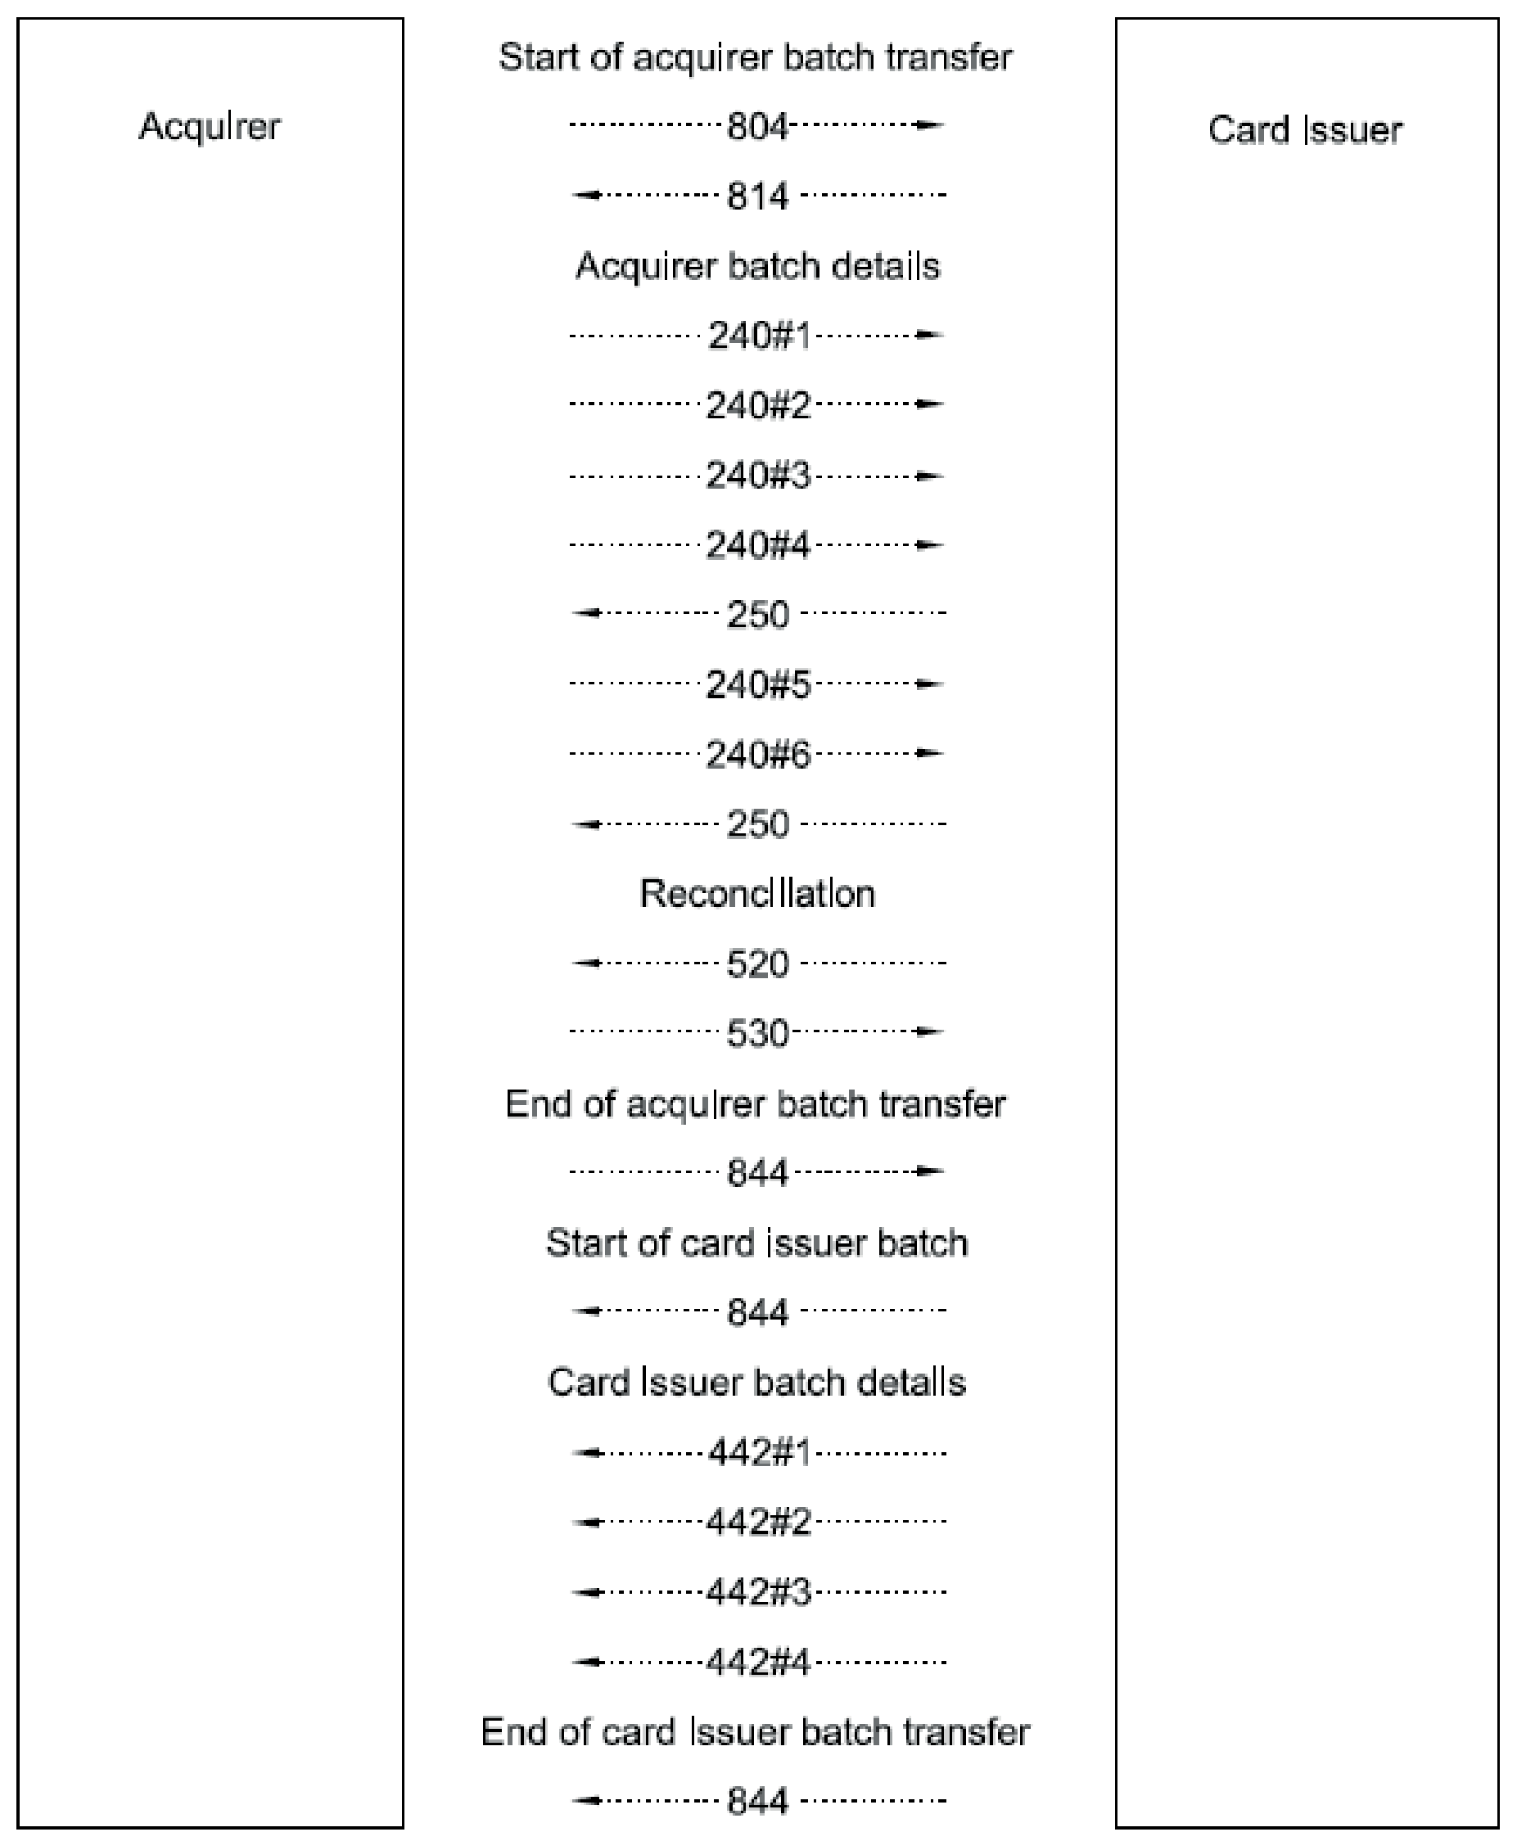

Figure G.1 — Example batch transfer message flows

Table G.1 — Start of acquirer batch transfer
MTI | Bit | Data element name | Value | Meaning
804 | Acquirer to card issuer
 | 24 | Function code | 841 | Start batch transfer
 | 25 | Message reason code | 8000 | Start transfer, no recovery procedure
 | 69 | Batch/file transfer control data
 |  | Batch/file transfer message count | 00000006 | Number of messages in the batch
 |  | Batch/file transfer file identification | ..test batch 1 | Batch name
814 | Card issuer to acquirer
 | 24 | Function code | 841 | Start batch transfer
 | 39 | Action code | 8000 | Accepted
 | 69 | Batch/file transfer control data
 |  | Batch/file transfer message count | 00000006 | Number of messages in the batch
 |  | Batch/file transfer file identification | ..test batch 1 | Batch name

Table G.2 — Acquirer batch details
MTI | Bit | Data element name | Value | Meaning
240 | Acquirer to card issuer
 | 68 | Batch/file transfer message control
 |  | Batch/file transfer acknowledgement code | 0 | No acknowledgement required
 |  | Batch/file transfer message sequence number | 00000001 | First message
240 | Acquirer to card issuer
 | 68 | Batch/file transfer message control
 |  | Batch/file transfer acknowledgement code | 0 | No acknowledgement required
 |  | Batch/file transfer message sequence number | 00000002 | Second message
240 | Acquirer to card issuer
 | 68 | Batch/file transfer message control
 |  | Batch/file transfer acknowledgement code | 0 | No acknowledgement required
 |  | Batch/file transfer message sequence number | 00000003 | Third message
240 | Acquirer to card issuer
 | 68 | Batch/file transfer message control
 |  | Batch/file transfer acknowledgement code | 1 | Acknowledgement required
 |  | Batch/file transfer message sequence number | 00000004 | Fourth message
250 | Card issuer to acquirer
 | 68 | Batch/file transfer message control
 |  | Batch/file transfer acknowledgement code | 3 | Positive acknowledgement
 |  | Batch/file transfer message sequence number | 00000004 | All messages up to the fourth one correctly received
240 | Acquirer to card issuer
 | 68 | Batch/file transfer message control
 |  | Batch/file transfer acknowledgement code | 0 | No acknowledgement required
 |  | Batch/file transfer message sequence number | 00000005 | Fifth message
240 | Acquirer to card issuer
 | 68 | Batch/file transfer message control
 |  | Batch/file transfer acknowledgement code | 2 | Acknowledgement required, end of transfer
 |  | Batch/file transfer message sequence number | 00000006 | Sixth message
250 | Card issuer to acquirer
 | 68 | Batch/file transfer message control
 |  | Batch/file transfer acknowledgement code | 3 | Positive acknowledgement
 |  | Batch/file transfer message sequence number | 00000006 | All messages up to the sixth one correctly received

Table G.3 — Reconciliation
MTI | Bit | Data element name | Value | Meaning
520 | Acquirer to card issuer
530 | Card issuer to acquirer
 | 39 | Action code | 8000 | Accepted

Table G.4 — End of acquirer batch transfer
MTI | Bit | Data element name | Value | Meaning
844 | Acquirer to card issuer
 | 24 | Function code | 842 | End of batch transfer
 | 25 | Message reason code | 8002 | End batch
 | 69 | Batch/file transfer control data
 |  | Batch/file transfer message count | 0000000 | Number of messages in the batch
 |  | Batch/file transfer file identification | ..test batch 1 | Batch name

Example of management of negative acknowledgement
This example shows how an acquirer-initiated batch transfer with a negative acknowledgement for a financial presentment notification message is managed.
The following parameters are assumed:
a) batch transfer is initiated by the acquirer;
b) batch transfer consists of seven financial presentment notifications with a frequency of acknowledgement every three messages with a negative acknowledgement and a repeat requested on the fifth financial presentment notification message.
Figure G.2 shows the message flows and Table G.5 to Table G.11 give the relevant data element contents.
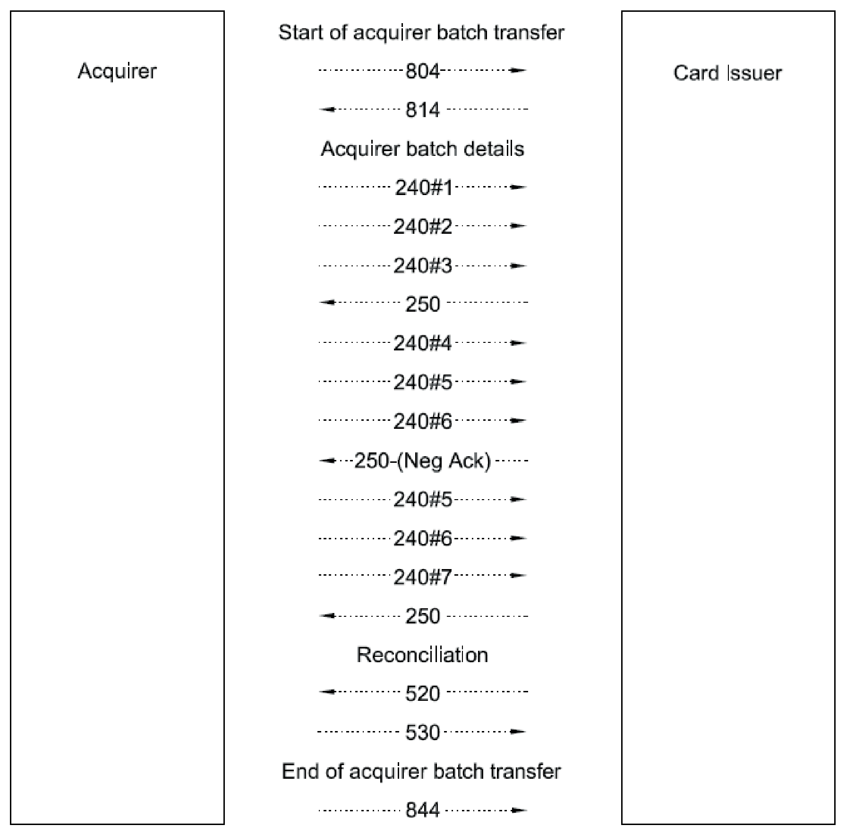

Figure G.2 — Example of negative acknowledgement message flows

Table G.5 — Start of acquirer batch transfer
MTI | Bit | Data element name | Value | Meaning
804 | Acquirer to card issuer
 | 24 | Function code | 841 | Start batch transfer
 | 25 | Message reason code | 8000 | Start transfer, no recovery procedure
 | 69 | Batch/file transfer control data
 |  | Batch/file transfer message count | 00000006 | Number of messages in the batch
 |  | Batch/file transfer file identification | ..test batch 1 | Batch name
814 | Card issuer to acquirer
 | 24 | Function code | 841 | Start batch transfer
 | 39 | Action code | 8000 | Accepted
 | 69 | Batch/file transfer control data
 |  | Batch/file transfer message count | 00000006 | Number of messages in the batch
 |  | Batch/file transfer file identification | ..test batch 1 | Batch name

Table G.6 — Acquirer batch details
MTI | Bit | Data element name | Value | Meaning
240 | Acquirer to card issuer
 | 68 | Batch/file transfer message control
 |  | Batch/file transfer acknowledgement code | 0 | No acknowledgement required
 |  | Batch/file transfer message sequence number | 00000001 | First message
240 | Acquirer to card issuer
 | 68 | Batch/file transfer message control
 |  | Batch/file transfer acknowledgement code | 0 | No acknowledgement required
 |  | Batch/file transfer message sequence number | 00000002 | Second message
240 | Acquirer to card issuer
 | 68 | Batch/file transfer message control
 |  | Batch/file transfer acknowledgement code | 1 | Acknowledgement required
 |  | Batch/file transfer message sequence number | 00000003 | Third message
250 | Card issuer to acquirer
 | 68 | Batch/file transfer message control
 |  | Batch/file transfer acknowledgement code | 3 | Positive acknowledgement
 |  | Batch/file transfer message sequence number | 00000003 | All messages up to the third one correctly received
240 | Acquirer to card issuer
 | 68 | Batch/file transfer message control
 |  | Batch/file transfer acknowledgement code | 0 | No acknowledgement required
 |  | Batch/file transfer message sequence number | 00000004 | Fourth message
240 | Acquirer to card issuer
 | 68 | Batch/file transfer message control
 |  | Batch/file transfer acknowledgement code | 0 | No Acknowledgement required
 |  | Batch/file transfer message sequence number | 00000005 | Fifth message
240 | Acquirer to card issuer
 | 68 | Batch/file transfer message control
 |  | Batch/file transfer acknowledgement code | 1 | Acknowledgement required
 |  | Batch/file transfer message sequence number | 00000006 | Sixth message
250 | Card issuer to acquirer
 | 68 | Batch/file transfer message control
 |  | Batch/file transfer acknowledgement code | 7 | Negative acknowledgement, repeat requested
 |  | Batch/file transfer message sequence number | 00000005 | All messages up to the fifth one correctly received
240 | Acquirer to card issuer
 | 68 | Batch/file transfer message control
 |  | Batch/file transfer acknowledgement code | 0 | No acknowledgement required
 |  | Batch/file transfer message sequence number | 00000005 | Fifth message
240 | Acquirer to card issuer
 | 68 | Batch/file transfer message control
 |  | Batch/file transfer acknowledgement code | 0 | No acknowledgement required
 |  | Batch/file transfer message sequence number | 00000006 | Sixth message
240 | Acquirer to card issuer
 | 68 | Batch/file transfer message control
 |  | Batch/file transfer acknowledgement code | 2 | Acknowledgement required, end of transfer
 |  | Batch/file transfer message sequence number | 00000007 | Seventh message
250 | Card issuer to acquirer
 | 68 | Batch/file transfer message control
 |  | Batch/file transfer acknowledgement code | 3 | Positive acknowledgement
 |  | Batch/file transfer message sequence number | 00000007 | All messages up to the seventh one correctly received

Table G.7 — Reconciliation
MTI | Bit | Data element name | Value | Meaning
520 | Acquirer to card issuer
530 | Card issuer to acquirer
 | 39 | Action code | 8000 | Accepted

Table G.8 — End of acquirer batch transfer
MTI | Bit | Data element name | Value | Meaning
844 | Acquirer to card issuer
 | 24 | Function code | 842 | End of batch transfer
 | 25 | Message reason code | 8002 | End batch
 | 69 | Batch/file transfer control data
 |  | Batch/file transfer message count | 0000000 | Number of messages in the batch
 |  | Batch/file transfer file identification | ..test batch 1 | Batch name

Table G.9 — Start of card issuer batch transfer
MTI | Bit | Data element name | Value | Meaning
844 | Card issuer to acquirer
 | 24 | Function code | 841 | Start batch transfer
 | 25 | Message reason code | 8000 | Start transfer, no recovery procedure
 | 69 | Batch/file transfer control data
 |  | Batch/file transfer message count | 00000004 | Number of messages in the batch
 |  | Batch/file transfer file identification | ..test batch 2 | Batch name

Table G.10 — Card issuer batch details
MTI | Bit | Data element name | Value | Meaning
442 | Card issuer to acquirer
 | 68 | Batch/file transfer message control
 |  | Batch/file transfer acknowledgement code | 0 | No acknowledgement required
 |  | Batch/file transfer message sequence number | 00000001 | First message
442 | Card issuer to acquirer
 | 68 | Batch/file transfer message control
 |  | Batch/file transfer acknowledgement code | 0 | No acknowledgement required
 |  | Batch/file transfer message sequence number | 00000002 | Second message
442 | Card issuer to acquirer
 | 68 | Batch/file transfer message control
 |  | Batch/file transfer acknowledgement code | 0 | No acknowledgement required
 |  | Batch/file transfer message sequence number | 00000003 | Third message
442 | Card issuer to acquirer
 | 68 | Batch/file transfer message control
 |  | Batch/file transfer acknowledgement code | 0 | No acknowledgement required
 |  | Batch/file transfer message sequence number | 00000004 | Fourth message

Table G.11 — End of card issuer batch transfer
MTI | Bit | Data element name | Value | Meaning
844 | Card issuer to acquirer
 | 24 | Function code | 842 | End of batch transfer
 | 25 | Message reason code | 8002 | End batch
 | 69 | Batch/file transfer control data
 |  | Batch/file transfer message count | 0000000 | Number of messages in the batch
 |  | Batch/file transfer file identification | ..test batch 2 | Batch name

Example of the management of interruptions
This example shows how a restart is managed if an interruption occurs during a batch transfer. The following parameters are assumed:
a) batch transfer is initiated by the acquirer;
b) batch consists of seven financial presentment notifications with a frequency of acknowledgement every four messages.
Figure G.3 shows the messages flows and Table G.12 to Table G.15 give the relevant data element contents.
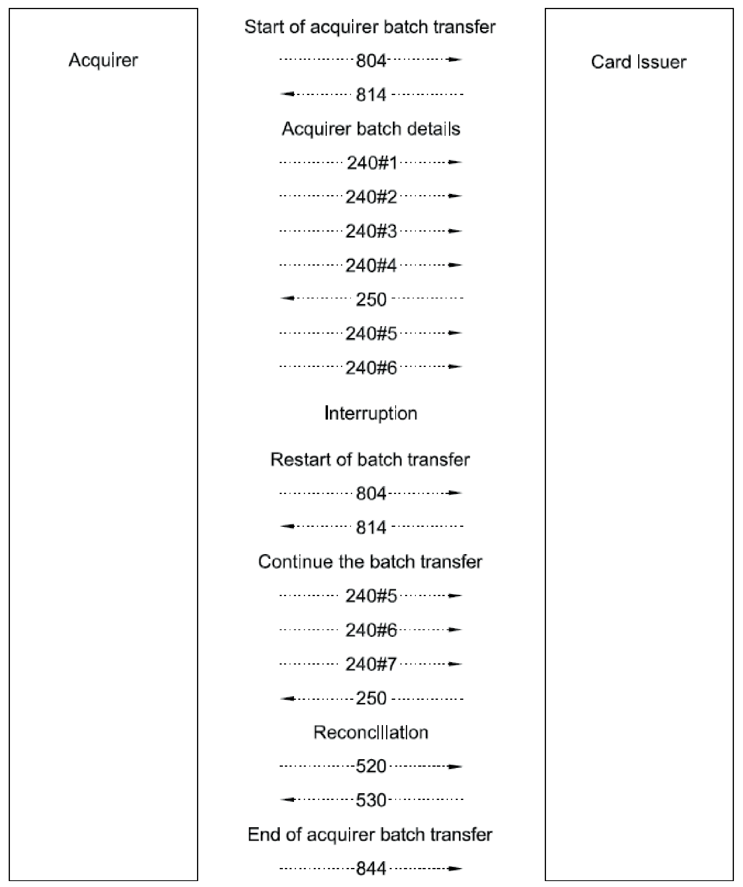

Figure G.3 — Example of the management of interruptions message flows

Table G.12 — Start of acquirer batch transfer
MTI | Bit | Data element name | Value | Meaning
804 | Acquirer to card issuer
 | 24 | Function code | 841 | Start of batch/file transfer
 | 25 | Message reason code | 8000 | Start transfer, no recovery procedure
 | 69 | Batch/file transfer control data
 |  | Batch/file transfer message count | 00000007 | Number of messages in the batch
 |  | Batch/file transfer file identification | ..test batch 3 | Batch name
814 | Card issuer to acquirer
 | 24 | Function code | 841 | Start batch transfer
 | 25 | Message reason code | 8000 | Start transfer, no recovery procedure
 | 69 | Batch/file transfer control data
 |  | Batch/file transfer message count | 00000007 | Number of messages in the batch
 |  | Batch/file transfer file identification | ..test batch 3 | Batch name

Table G.13 — Acquirer batch details
MTI | Bit | Data element name | Value | Meaning
240 | Acquirer to card issuer
 | 68 | Batch/file transfer message control
 |  | Batch/file transfer acknowledgement code | 0 | No acknowledgement required
 |  | Batch/file transfer message sequence number | 00000001 | First message
240 | Acquirer to card issuer
 | 68 | Batch/file transfer message control
 |  | Batch/file transfer acknowledgement code | 0 | No acknowledgement required
 |  | Batch/file transfer message sequence number | 00000002 | Second message
240 | Acquirer to card issuer
 | 68 | Batch/file transfer message control
 |  | Batch/file transfer acknowledgement code | 1 | Acknowledgement required
 |  | Batch/file transfer message sequence number | 00000003 | Third message
250 | Card issuer to acquirer
 | 68 | Batch/file transfer message control
 |  | Batch/file transfer acknowledgement code | 3 | Positive acknowledgement
 |  | Batch/file transfer message sequence number | 00000003 | All messages up to the third one correctly received
240 | Acquirer to card issuer
 | 68 | Batch/file transfer message control
 |  | Batch/file transfer acknowledgement code | 0 | No acknowledgement required
 |  | Batch/file transfer message sequence number | 00000004 | Fourth message
240 | Acquirer to card issuer
 | 68 | Batch/file transfer message control
 |  | Batch/file transfer acknowledgement code | 0 | No Acknowledgement required
 |  | Batch/file transfer message sequence number | 00000005 | Fifth message
240 | Acquirer to card issuer
 | 68 | Batch/file transfer message control
 |  | Batch/file transfer acknowledgement code | 1 | Acknowledgement required
 |  | Batch/file transfer message sequence number | 00000006 | Sixth message
250 | Card issuer to acquirer
 | 68 | Batch/file transfer message control
 |  | Batch/file transfer acknowledgement code | 7 | Negative acknowledgement, repeat requested
 |  | Batch/file transfer message sequence number | 00000005 | All messages up to the fifth one correctly received
240 | Acquirer to card issuer
 | 68 | Batch/file transfer message control
 |  | Batch/file transfer acknowledgement code | 0 | No acknowledgement required
 |  | Batch/file transfer message sequence number | 00000005 | Fifth message
240 | Acquirer to card issuer
 | 68 | Batch/file transfer message control
 |  | Batch/file transfer acknowledgement code | 0 | No acknowledgement required
 |  | Batch/file transfer message sequence number | 00000006 | Sixth message
240 | Acquirer to card issuer
 | 68 | Batch/file transfer message control
 |  | Batch/file transfer acknowledgement code | 2 | Acknowledgement required, end of transfer
 |  | Batch/file transfer message sequence number | 00000007 | Seventh message
250 | Card issuer to acquirer
 | 68 | Batch/file transfer message control
 |  | Batch/file transfer acknowledgement code | 3 | Positive acknowledgement
 |  | Batch/file transfer message sequence number | 00000007 | All messages up to the seventh one correctly received

Table G.14 — Reconciliation
MTI | Bit | Data element name | Value | Meaning
520 | Acquirer to card issuer
530 | Card issuer to acquirer
 | 39 | Action code | 8000 | Accepted

Table G.15 — End of acquirer batch transfer
MTI | Bit | Data element name | Value | Meaning
844 | Acquirer to card issuer
 | 24 | Function code | 842 | End batch transfer
 | 25 | Message reason code | 8002 | End batch
 | 69 | Batch/file transfer control data
 |  | Batch/file transfer message count | 0 | Number of messages in the batch
 |  | Batch/file transfer file identification | ..test batch 3 | Batch name

Example of a simple batch transfer
This example shows a simple batch transfer with no other activity. The following parameters are assumed:
a) batch transfer is initiated by acquirer;
b) batch consists of three financial presentment notifications and one fee collection message;
c) there are no acknowledgements.
Figure G.4 shows the messages flows and Table G.16 to Table G.21 give the relevant data element contents.
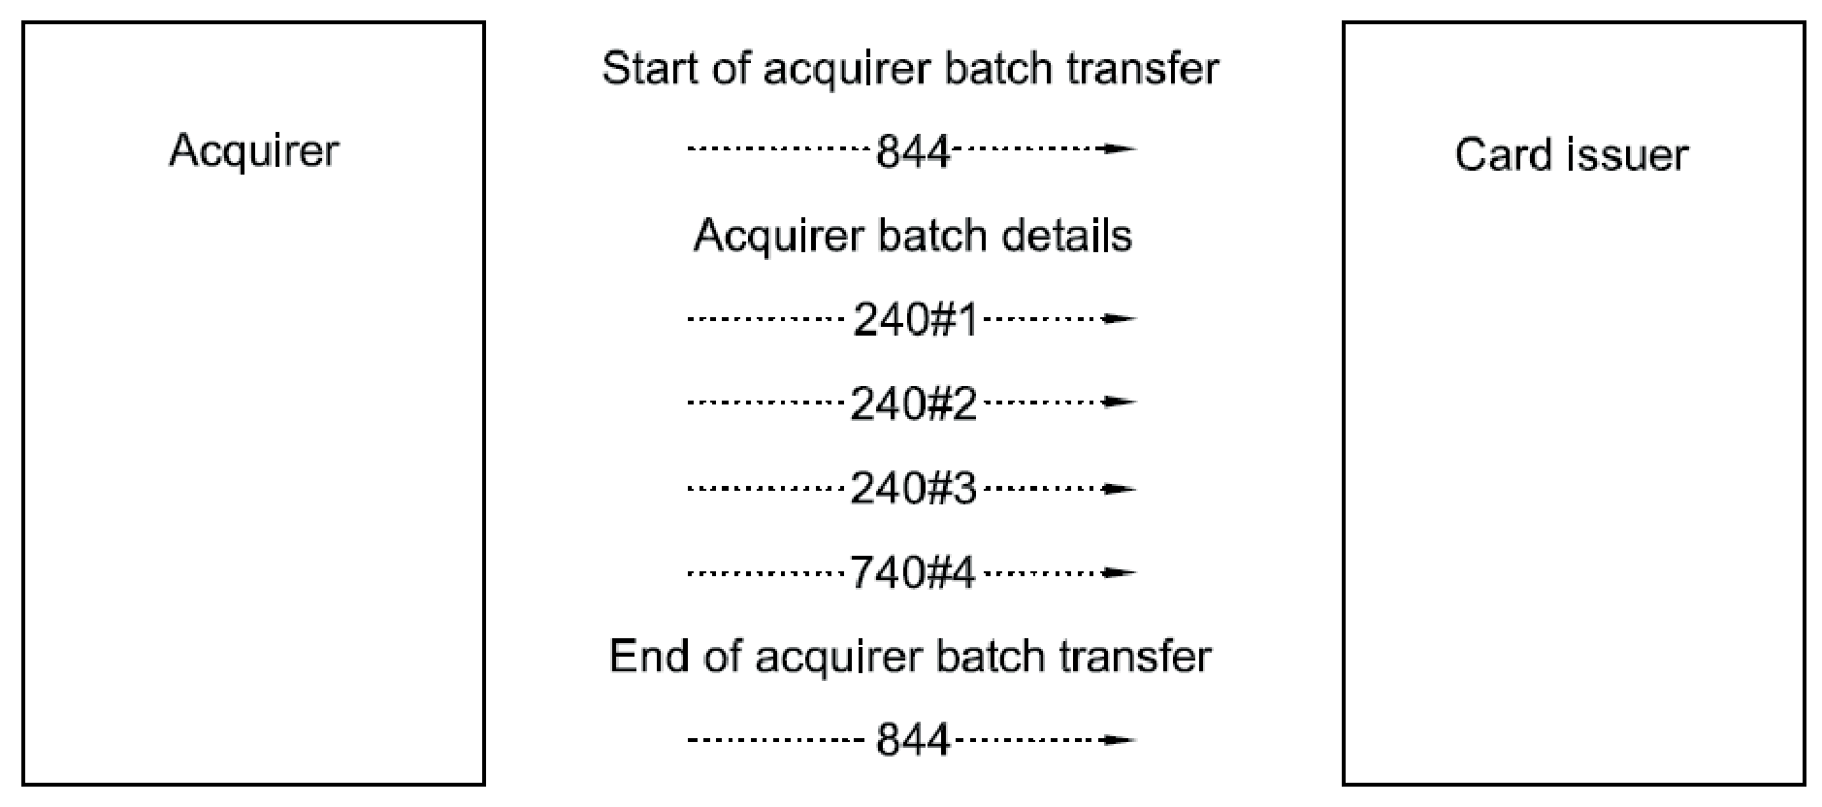

Figure G.4 — Example simple batch transfer message flows

Table G.16 — Start of acquirer batch transfer
MTI | Bit | Data element name | Value | Meaning
804 | Acquirer to card issuer
 | 24 | Function code | 841 | Start batch transfer
 | 25 | Message reason code | 8000 | Start transfer, no recovery procedure
 | 69 | Batch/file transfer control data
 |  | Batch/file transfer message count | 00000007 | Number of messages in the batch
 |  | Batch/file transfer file identification | ..test batch 4 | Batch name
814 | Card issuer to acquirer
 | 24 | Function code | 841 | Start batch transfer
 | 39 | Action code | 8000 | Accepted
 | 69 | Batch/file transfer control data
 |  | Batch/file transfer message count | 00000007 | Number of messages in the batch
 |  | Batch/file transfer file identification | test batch 4 | Batch name

Table G.17 — Acquirer batch details
MTI | Bit | Data element name | Value | Meaning
240 | Acquirer to card issuer
 | 68 | Batch/file transfer message control
 |  | Batch/file transfer acknowledgement code | 0 | No acknowledgement required
 |  | Batch/file transfer message sequence count | 00000001 | First message
240 | Acquirer to card issuer
 | 68 | Batch/file transfer message control
 |  | Batch/file transfer acknowledgement code | 0 | No acknowledgement required
 |  | Batch/file transfer message sequence count | 00000002 | Second message
240 | Acquirer to card issuer
 | 68 | Batch/file transfer message control
 |  | Batch/file transfer acknowledgement code | 0 | Acknowledgement required
 |  | Batch/file transfer message sequence count | 00000003 | Third message
240 | Acquirer to card issuer
 | 68 | Batch/file transfer message control
 |  | Batch/file transfer acknowledgement code | 1 | Acknowledgement required
 |  | Batch/file transfer message sequence count | 00000004 | Fourth message
250 | Card issuer to acquirer
 | 68 | Batch/file transfer message control
 |  | Batch/file transfer acknowledgement code | 3 | Positive acknowledgement
 |  | Batch/file transfer message sequence count | 00000004 | All messages up to the fourth one correctly received
240 | Acquirer to card issuer
 | 68 | Batch/file transfer message control
 |  | Batch/file transfer acknowledgement code | 0 | No acknowledgement required
 |  | Batch/file transfer message sequence count | 00000005 | Fifth message
240 | Acquirer to card issuer
 | 68 | Batch/file transfer message control
 |  | Batch/file transfer acknowledgement code | 0 | No acknowledgement required
 |  | Batch/file transfer message sequence count | 00000006 | Sixth message
Connection interrupted

Table G.18 — Restart of acquirer batch transfer
MTI | Bit | Data element name | Value | Meaning
 | Connection interrupted
804 | Acquirer to card issuer
 | 24 | Function code | 841 | Start batch transfer
 | 25 | Message reason code | 8001 | Start batch, recovery procedure
 | 69 | Batch/file transfer control data
 |  | Batch/file transfer message count | 00000007 | Number of financial presentment notifications
 |  | Batch/file transfer file identification | test batch 4 | File name
814 | Card issuer to acquirer
 | 24 | Function code | 841 | Start batch transfer
 | 39 | Action code | 8000 | Accepted
 | 69 | Batch/file transfer control data
 |  | Batch/file transfer message count | 00000007 | Number of financial presentment notifications
 |  | Batch/file transfer file identification | test batch 4 | File name

Table G.19 — Continue the batch transfer
MTI | Bit | Data element name | Value | Meaning
240 | Acquirer to card issuer
 | 68 | Batch/file transfer message control
 |  | Batch/file transfer acknowledgement code | 0 | No acknowledgement required
 |  | Batch/file transfer message sequence number | 00000005 | Fifth message
240 | Acquirer to card issuer
 | 68 | Batch/file transfer message control
 |  | Batch/file transfer acknowledgement code | 0 | No acknowledgement required
 |  | Batch/file transfer message sequence number | 00000006 | Sixth message
240 | Acquirer to card issuer
 | 68 | Batch/file transfer message control
 |  | Batch/file transfer acknowledgement code | 2 | Acknowledgement required, end of transfer
 |  | Batch/file transfer message sequence number | 00000007 | Seventh message
250 | Card issuer to acquirer
 | 68 | Batch/file transfer message control
 |  | Batch/file transfer acknowledgement code | 3 | Positive acknowledgement
 |  | Batch/file transfer message sequence number | 00000007 | All messages up to the seventh one correctly received

Table G.20 — Reconciliation
MTI | Bit | Data element name | Value | Meaning
520 | Acquirer to card issuer
530 | Card issuer to acquirer
 | 39 | Action code | 8000 | Accepted

Table G.21 — End of acquirer batch transfer
MTI | Bit | Data element name | Value | Meaning
844 | Acquirer to card issuer
 | 24 | Function code | 842 | End batch transfer
 | 25 | Message reason code | 8002 | End batch
 | 69 | Batch/file transfer control data
 |  | Batch/file transfer message count | 0000000 | Number of messages in the batch
 |  | Batch/file transfer file identification | test batch 4 | Batch name

